**Question: Create a t3a.micro ec2 instance in private subnet AWS or Azure instances using Terraform scripts. VPC, Subnet, RouteTable, SecurityGroup, Access Key and EC2 machines should all be created via terraform. Use of 1 self created module is mandatory for this assignment.**

**Solution:**

Created the terraform modularized code and which creating two terraforms: one for webserver ec2 and another for PC and its components. This way we can keep our code in a more manageable and readable way to provision our infrastructure.

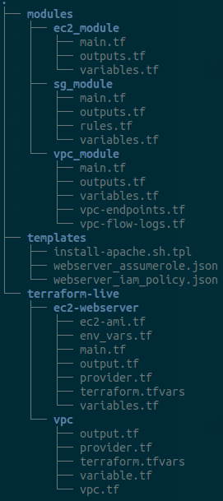

We need to initialize the terraform in terraform-live/vpc/ and terraform-live/ec2-webserver/ directories.

The modules folder has these specified resources module codes.

And the template folder has the documents containing the user data to install apache on ec2 and other IAM roles.

Apart from this, we are creating a vpc, four subnets (2 public and 2 private), two Route Tables, One IGW, and One NAT.

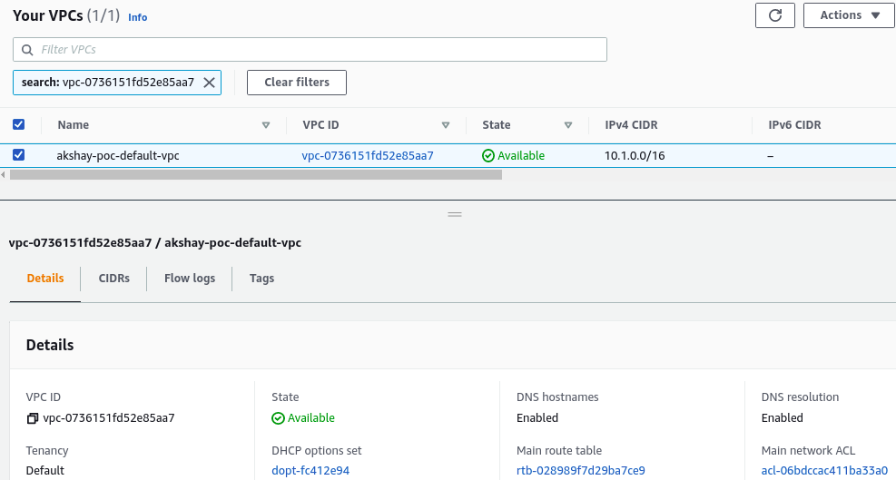

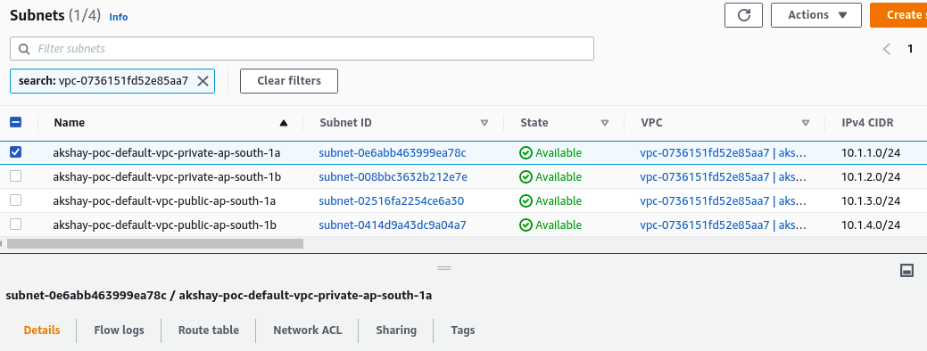

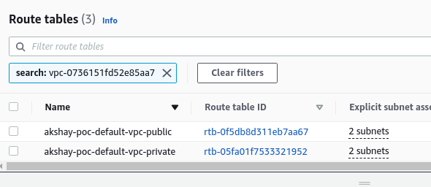

The server is launched in the private subnet and it is taking that subnet id from the data block thus we are not hard coding any values required among these two terraform directories.

